Headteacher
Mr Gareth Croxon B.Sc, NPQH
Owlsmoor Road, Owlsmoor, Sandhurst, Berkshire GU47 0SD
Tel: (01344)775678
Website: www.sandhurstschool.org.uk
E-mail: contactus@sandhurstschool.org.uk

22nd September 2023

Dear Parent/Carer(s),
Re: Free School Meals Eligibility
We know that many of you have had to go through financial changes as a result of the pandemic and may now be struggling financially. It may be that you are now eligible to access free school meals.
If children who are eligible for free school meals or have been eligible in the past six years (known as Ever6) are registered then the funding we can access is known as the Pupil Premium. For every child registered we get £955 per year.
With this money, as well as providing a school lunch for those eligible, we are also able to employ more staff, creating time for extra support in Maths and English and have been able to purchase a new reading scheme. The continued success of the Student Learning Centre in supporting the pastoral welfare of some of our most vulnerable students relies on pupil premium funding and the ability to subsidise uniform or equipment costs and school visits for our students too. In order to register – first check if you qualify. It is not just if you are unemployed. Registration is confidential and will not affect other benefits you may be claiming.
You can check if you qualify and register your child for Free School Meals by visiting the local authority website:
www.bracknell-forest.gov.uk/schools-and-learning/schools/free-school-meals
Pupil Premium Funding is also available for service children and children looked after by the Local Authority.
By being registered you will be able to benefit by accessing funds to support your child, for example:
- New school uniform
- School visits
- Text books and revision guides
- Material costs for design technology
- A lunchtime meal
If you cannot apply online, you can call customer services on 01344 352000.
If you don’t want your child to have the school meal they don’t have to, but as long as you qualify and are registered, the school still gets the extra £955.
Yours sincerely,
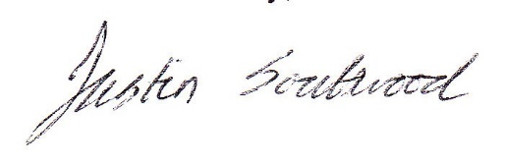

Mr Justin Southwood
Deputy Headteacher

