

Headteacher

Debbie Smith B.Ed, NPQH

**Sandhurst School**

**GUIDANCE FOR STUDENTS & PARENTS**

**EXTERNAL EXAMINATIONS**

**Centre Number: 51115**



This information is to help you with valuable advice for examinations held at   
Sandhurst School.

**You are required to read this document carefully and retain it for future reference**

If you have **ANY** questions or problems, please contact the Exams Office.

# CONTENTS

INTRODUCTION 3

CONTACT NUMBERS 3

BEFORE THE EXAMINATIONS 4

Statements of Entry/Timetable: 4

Examination Boards 4

Candidate Name: 4

Candidate Number: 4

Timetables 4

Examination Clashes 4

Special Arrangements 5

Special Consideration 5

Equipment 5

DURING THE EXAMINATIONS 5

Examination Regulations 5

Attendance at Examinations 6

INVIGILATORS 7

ABSENCE FROM EXAMINATIONS 7

What to do if you are ill on the day of an exam 7

EXAM CHECK LIST 8

EXAM RESULT DAY 8

UNDERSTANDING EXAM PAPERWORK 9

Results 9

EXAM NOTICES 10

# INTRODUCTION

It is the aim of Sandhurst School to make the examination experience as stress-free and successful as possible for all candidates.

Hopefully, this booklet will prove informative and helpful for you and your parents. Please read it carefully and show it to your parents so that they are also aware of the examination regulations and the procedures which must be followed in the event of any problems occurring.

The awarding bodies (examination boards) set down strict criteria which must be followed for the conduct of examinations and Sandhurst School is required to follow them precisely. You should therefore, pay particular attention to the **JCQ (Joint Council For Qualifications) INFORMATION FOR CANDIDATES** that can be accessed on the school website.

Some of the questions you may have are answered at the back of this booklet. If there is anything you do not understand or any question that has not been addressed, **PLEASE ASK NOW!**

# CONTACT NUMBERS

* Please check that school has at least one up-to-date contact number and email address for you.
* If you have any queries or need help or advice at any time before, during or after the examinations please contact a member of the exams team:
* The school telephone number is: 01344-775678

Remember – we are here to help.

**GOOD LUCK!**

# BEFORE THE EXAMINATIONS

## Statements of Entry/Timetable:

All Candidates will receive a Statement of Entry from school indicating the subjects they are being entered for and the levels of entry, where applicable. Please check that these are correct. Some subjects only have one tier of entry, some have Foundation or Higher Tiers.

## Examination Boards

Your School use the following Exam Boards: AQA, OCR, Pearson Edexcel, WJEC, City & Guilds.

## Candidate Name:

It is important that you check your name is spelt correctly on your timetable as this will appear on your certificates when they are printed.

## Candidate Number:

Each candidate has a four-digit candidate number. This is the number you will enter on examination papers. Please remember it. This number will be written on a card which will be on your exam desk for each exam.

## Timetables

Make sure you know the dates and times of your examinations. If you miss a Public Examination **you cannot take that paper at any other time**.

Unless notified otherwise:

* Morning exams start at **9.00am**
* Afternoon exams start at **1.30pm**

**YOU MUST BE AT THE GYM 15 MINUTES BEFORE THESE TIMES.**

It is your responsibility to turn up on time for the examination so make sure that you and your parents know the dates and times of each of your exams. If you are late for an exam you may not get the full time and the Examination Board may not accept your paper depending on the circumstances. **If you know that you are going to be late contact the school (01344-775678) so that the Exams Officer and invigilators know that you will be arriving late.**

Your timetable is your proof that you have been entered for a particular exam. If your timetable contains any errors you must see the Exams Officer immediately.

## Examination Clashes

A few candidates may have a clash where two subjects are timetabled at the same time. The school will make special timetable arrangements for these candidates only. You must check your individual timetable and see the Exams Officer immediately if you think there is a clash on your timetable.

## Special Arrangements

Special arrangements, including extra time, may be approved for candidates with:

* Physical difficulties;
* Language difficulties;
* Specific learning difficulties.

These are managed by the Access Arrangements Co-ordinator and the SENCo.

## Special Consideration

If you are fully prepared for an examination, but are ill on or just before the day of an examination, an application may be made for special consideration for the examination affected. Examination Boards decide on the validity of each application. To support the application for Special Consideration, you will be required to provide a doctors certificate.

## Equipment

**MAKE SURE YOU HAVE ALL THE CORRECT EQUIPMENT BEFORE YOUR EXAMINATIONS.** Check the regulations in the JCQ INFORMATION FOR CANDIDATES found on our website and the information on the following pages.

You must provide all your own equipment. Borrowing from other candidates is **NOT** allowed under any circumstances. You must bring your equipment in a transparent pencil case.

The following equipment should be brought to EVERY exam:

* 2 pens – **black** only (erasable pens are not permitted)
* 2 HB pencils
* Ruler (marked with millimetres)
* Pencil sharpener (preferably one which catches the shavings!)
* Rubber

For certain exams you will also need the following:

* Compasses
* Protractor
* Calculator (lid removed) – please make sure they comply with exam board regulations
* Colouring pencils

You are not allowed to use correction fluid.

* Highlighter pens are not allowed to be used on your answer booklet but may be used on the questions.

# DURING THE EXAMINATIONS

## Examination Regulations

A copy of the JCQ ‘INFORMATION FOR CANDIDATES’, which is issued jointly by all the Examining Boards can be found on the school website under ‘Parents/Exam Information’. All candidates must read this carefully and note that to break any of the examination rules or regulations could lead to disqualification from all subjects. The school must report any breach of regulations to the Awarding Body.

## Attendance at Examinations

Candidates are responsible for checking their own timetable and arriving at school on the correct day and time, properly dressed and equipped. Candidates must arrive 15 minutes prior to the start time of their examination. Please wait quietly in the gym where you will be given final instructions and then you will be invited to enter the exam hall by the exam invigilators.

* Candidates who arrive late for an examination may still be allowed to enter the exam room and sit the exam. This is entirely at the discretion of the school.
* Full School Uniform must be worn by all students attending school for examinations, summer uniform is acceptable.
* Do not attempt to communicate with, or distract other candidates.
* Examination regulations are very strict regarding items that may be taken into the examination room. If you break these rules you will be disqualified from the examination. Mobile phones and/or any other electrical equipment **MUST BE TURNED OFF AND PLACED IN YOUR BAG** having them on silent is not acceptable. All watches must be removed and placed in your bag.
* If you are found with a mobile phone once the exam has started the exam board must be informed and you could be disqualified from this and possible future examinations.
* No food is allowed in the exam rooms. However, water bottles are allowed, these MUST be clear bottles with a spill-proof cap. There MUST be no label on the bottle and must ONLY contain water. They must be placed on the floor next to your desk.
* Please do not write on examination desks. This is regarded as vandalism and you will be asked to pay for any damage. Remember we have a plan, we know where you were sitting.
* Do not draw graffiti or write comments on examination papers – if you do the examination board may refuse to accept your paper.
* Listen carefully to instructions and notices read out by the invigilators – there may be amendments to the exam paper that you need to know about.
* Check you have the correct question paper – check the subject, paper and tier of entry. Read all instructions carefully and number your answers clearly.
* You will not be allowed to leave an examination room early. If you have finished the paper use any time remaining to re-read the questions, check over your answers and that you have completed your details correctly.
* At the end of the examination all work must be handed in – remember to cross out any rough work that you do not want marked. If you have used more than one answer book or loose sheets of paper ask for a tag to fasten them together in the correct order.
* Invigilators will collect your exam papers before you leave the room. **ABSOLUTE SILENCE** must be maintained during this time. Remember you are still under examination conditions until you have left the room.
* Question papers, answer booklets and additional paper must NOT be taken from the exam room.
* Remain seated in silence until told to leave the exam room. Please leave the room in silence and show consideration for other candidates who may still be working.
* If the FIRE ALARM sounds during an examination the exam invigilators will tell you what to do. If you have to evacuate the room you MUST leave in silence and in the order in which you are sitting. You will be escorted to a designated assembly point. Leave everything on your desk. You must not attempt to communicate with anyone else during the evacuation. When you return to the exam room, do not start writing until the invigilator tells you to do so. You will be allowed the full working time for the examination and a report will be sent to the awarding body detailing the incident.

# INVIGILATORS

The school employs invigilators to conduct the examinations. Students are expected to behave in a respectful manner towards all invigilators and follow their instructions at all times.

Invigilators are in the examination rooms to supervise the conduct of the examination and to ensure all exam regulations are adhered to. They will distribute and collect the exam papers, tell candidates when to start and finish the exam, hand out extra writing paper if required and deal with any problems that occur during the examination, for example if a candidate is feeling ill.

**Please note that invigilators cannot discuss the examination paper with you or explain the questions.**

Pupils who are disruptive or behave in an unacceptable manner will be removed from the examination room by invigilators and members of the Senior Leadership Team.

# ABSENCE FROM EXAMINATIONS

## What to do if you are ill on the day of an exam

If you are ill and are unable to attend an exam it is vital you phone the school first thing in the morning (01344 775678) to inform us.

You must also obtain a letter from your doctor detailing the reason for non-attendance. There is the possibility of submitting this note to the Examinations Board to ask for special consideration. The Board looks at this in conjunction with other exam marks from the student in that particular subject, coursework marks and mock exam marks. This will sometimes enable them to adjust the mark and grade accordingly.

If you are feeling unwell, but still able to attend school, you should come to the exam and we can assess the situation then. In most cases it is better to take the exam if you can.

**If in doubt – TELEPHONE THE SCHOOL**

Please note that misreading the timetable will not be accepted as a satisfactory explanation of absence. Sometimes in the past, students have had problems getting to an exam on time. This can be as a result of car breakdown, traffic jams, buses not turning up etc.

Although we encourage all students to arrive in plenty of time for all exams, so that there is not a last minute panic, it is important that we have up-to-date contact telephone numbers for your parents/carers, or anybody else who might be able to help in an emergency.

If you are late for an exam, we may not be able to get the exam paper accepted by the Exam Board.

We also suggest that your parents save the school telephone number on their mobile phone so you or they can call in if you have a serious problem on your journey to school: **01344-775678.**

# EXAM CHECK LIST

* You must arrive at school 15 minutes prior to an exam AT THE LATEST. It is much better to leave yourself a safety margin on timings in case of problems with the journey.
* Phones – Students must not have mobiles phones in their possession (either on or off). They must be switched off and placed in your bag or locker.
* Do not take into the exam any unauthorised electronic devices; stereos, digital equipment, reading pens, electronic communication/storage devices, iPods, MP3/4 players, smart watches or any other products with text/digital facilities.
* You should bring 2 black pens, pencil, rubber and any other writing equipment needed for your exams. Only clear pencil cases are allowed on your desk; any others should be left in your bag. Do not use gel pens – this is because many of the exam papers are now scanned and sent electronically for marking – gel pens do not scan well.
* In an exam where you have the use of a calculator, you should not have a calculator cover on your desk.
* **Sshh!** There is absolutely no talking or ANY form of communication between students once you enter the exam room. If you have any questions, you should raise your hand once seated and an invigilator will come to you.
* Normal School Uniform rules apply.
* No food allowed in the exam hall (if you have a special requirement – please see The Exams Officer before the exams)
* Water bottles are allowed in the exam room. These should be clear bottles with a spill-proof cap. There should be no label on the bottle and must contain only water.

# EXAM RESULT DAYS (SUMMER)

A Level Thursday 18th August 2022 emailed to you between 9am-10am

GCSE Thursday 25th August 2022 emailed to you between 9am-10am

# UNDERSTANDING EXAM PAPERWORK

## Results

On results day you will receive a ‘Statement of Results’. THIS IS NOT YOUR FINAL CERTIFICATE. The statement lists ALL the exams you have taken and any components within the qualification.

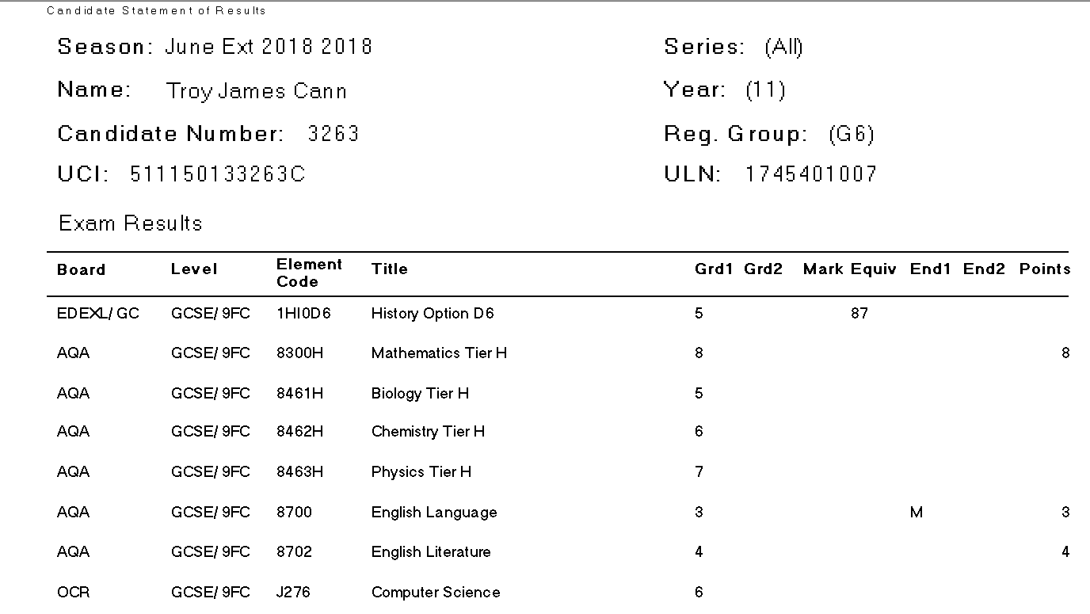

**1000**

Reg Group:

**0123456789789**

**000000061000B**

**Spoken Language Result: Pass, Merit, Distinction**

**Overall Result**

**Total marks for the qualification**

**Brittany Spears**

# 

# JCQ EXAM NOTICES

The following information can also be found on the school website.

<https://sandhurstschool.org.uk/parents-students/exam-information/>

JCQ (Joint Council for Qualifications)

* JCQ Information for Candidates for written examinations – please read this fully
* Guidance Handbook for Students and Parents
* JCQ No Mobile Phones
* JCQ Social Media
* JCQ Warning to Candidates

